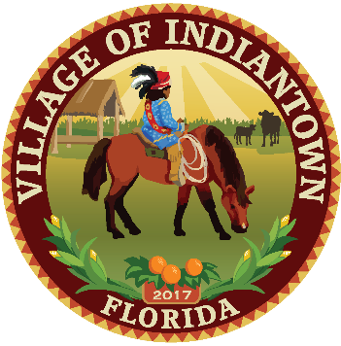
VILLAGE OF INDIANTOWN, FLORIDA
AGENDA COVER MEMORANDUM

MEETING DATE: May 9, 2024
MEETING TYPE: Village Council
AGENDA ITEM TITLE: Application No. RZ-24-010 Order granting a request to Rezone real property totaling 116-16-acres in size, south of SW Citrus Boulevard, north of SW Kanner Highway, from A-2 Agricultural zoning district to the Canal Mixed Use zoning district for Joseph W. Walsh & Indiantown Property Holdings, LLC.

SUMMARY OF ITEM: Joseph W. Walsh & Indiantown Property Holdings, LLC, (“Applicants”) are seeking a recommendation of approval from the Planning, Zoning and Appeals Board (“PZAB”) to rezone the subject property from A-2, Agricultural to Canal Mixed Use pursuant to Land Development Regulation Sec. 12-6. – Rezoning.
FISCAL IMPACT N/A

RECOMMENDATION: Village Staff recommend approval of the Rezoning Application RZ-24-010.

March 7, 2024, the PZAB/LPA recommended approval 4 to 1, with one PZAB board member absent.

March 14, 2024, the Village Council unanimously recommended approval.

PREPARED BY: Deanna Freeman, Community & Economic Development Director.

ATTACHMENTS: Staff Report
Presentation
Mailing Notice Affidavit
Public Notice Advertisement
Draft Adopting Ordinance

Application materials:

- Cover Letter.
- General Development application.
- Boundary Surveys.
- Narrative & Justification Statement.
- Description of Surrounding Properties & Uses.
Maps.
- Deeds.
- Legal Description.
- Exhibits.
- Affidavit – Notice & Signage Requirements.

