
Village of Indiantown
Planning, Zoning & Appeals Board
Staff Report
Beskar Investments, LLC

SECTION A: APPLICATION INFORMATION

Application Number ANX 24-072 - Beskar Voluntary Annexation

Project Name Beskar Investment LLC Voluntary Annexation

Hearing Date: July 2026

Date of Report July 2026

Property Owner/ Beskar Investments, LLC
Applicant Indiantown North, LLC
Indiantown II North, LLC
Indiantown II Mid, LLC
Jerry L. Emmert and Nicole L. Emmert, as Trustees
of the Jerry L. Emmert and Nicole L. Emmert Living Trust

Agent for Tyson Waters, Esq.
Applicant Fox McCluskey,
3461 SE Willoughby Blvd.
Stuart, FL 34994

Village Project Deanna Freeman,
Coordinator Community & Economic Development Director

SECTION B: PROJECT DESCRIPTION/DETAILS

Applicant Request

APPLICATION NO: ANX 24-072, REQUEST FOR APPROVAL OF ANNEXING BY VOLUNTARY PETITION CERTAIN REAL PROPERTY TOTALING +/-1,289.71-ACRES IN SIZE, LOCATED ON THE NORTH SIDE OF SW WARFIELD BOULEVARD, EAST OF SW FOX BROWN ROAD, WEST OF SW ALLAPATTAH ROAD, AND BOUNDED ON THREE SIDES BY THE MUNICIPAL BOUNDARIES OF THE VILLAGE OF INDIANTOWN.

Beskar Investments, LLC, Indiantown North, LLC, Indiantown II North, LLC, Indiantown II Mid, LLC, and Jerry L. Emmert and Nicole L. Emmert, as Trustees of the Jerry L. Emmert and Nicole L. Emmert Living Trust (“Applicant”) are seeking a recommendation of approval from the Planning, Zoning and Appeals Board (“PZAB”) for a Voluntary Annexation of nine (9) contiguous parcels of land into the municipal boundaries of the Village of Indiantown. The request is pursuant to Land Development Regulation Sec. 12-3. Annexation/contraction applications and the 2023 Florida Statutes Chapter 171.044.

Property Information

Location: The approximately 1,289.71-acre subject property is located on the north side of SW Warfield Boulevard, east of SW Fox Brown Road, west of SW Allapattah Road, and immediately bounded on three sides by the municipal boundaries of the Village of Indiantown.

Location & Jurisdictional Map:
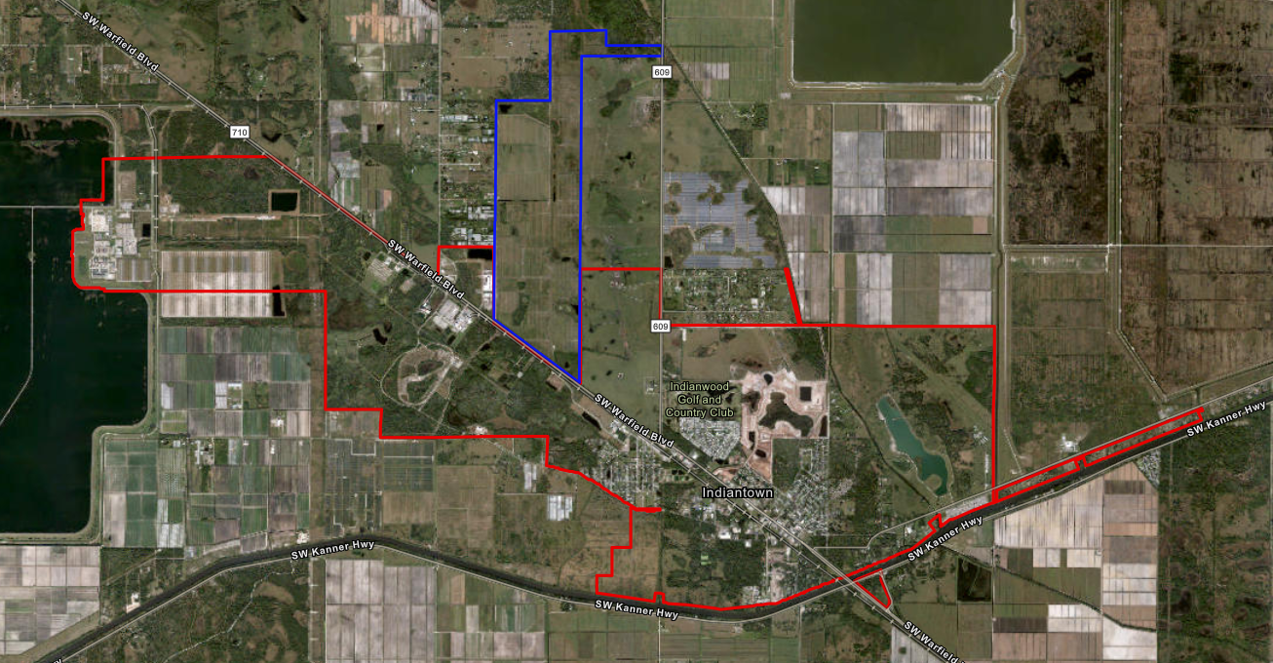

Aerial Map:
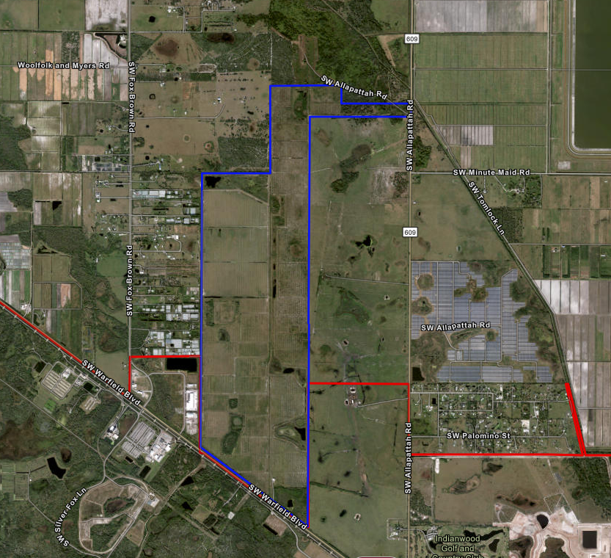
Existing Future Land Use Maps: Martin County & Village of Indiantown
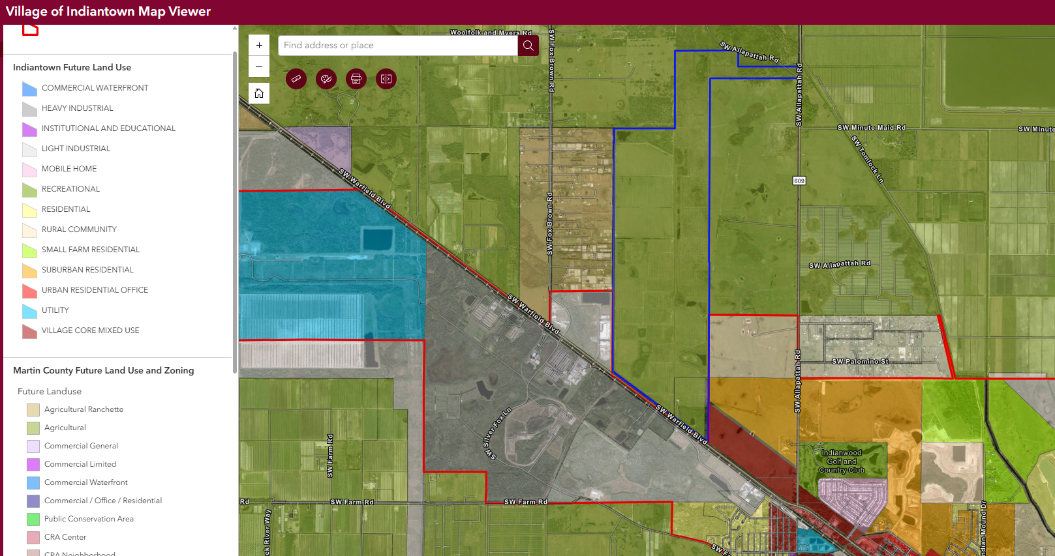

Existing Zoning Maps Martin County & Village of Indiantown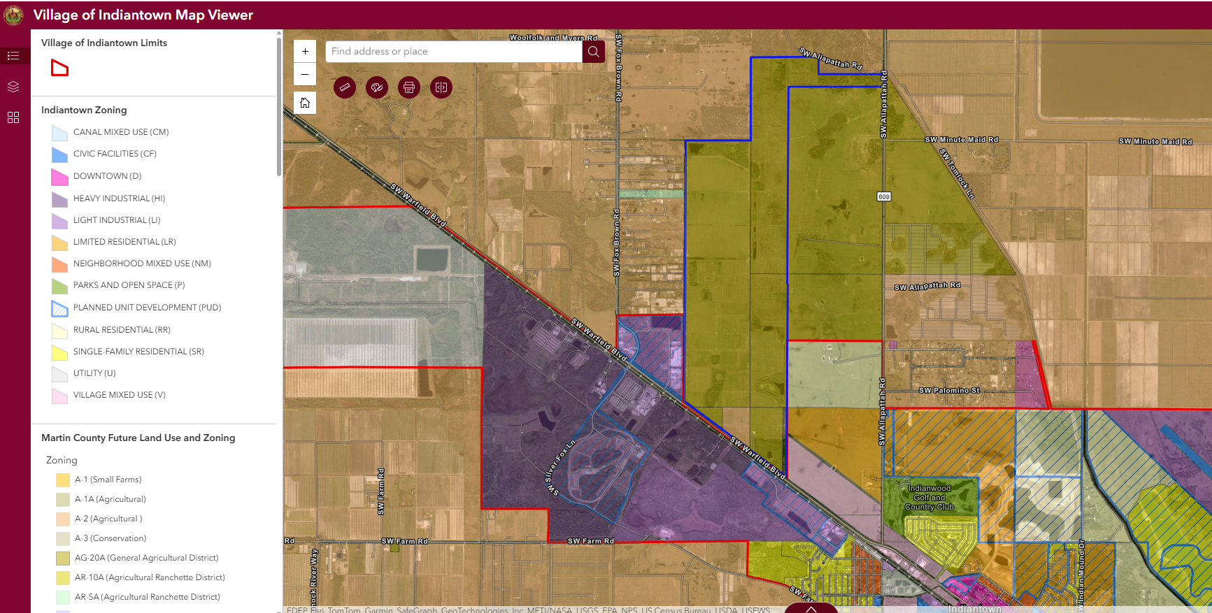

Proposed Village of Indiantown Jurisdictional Boundary
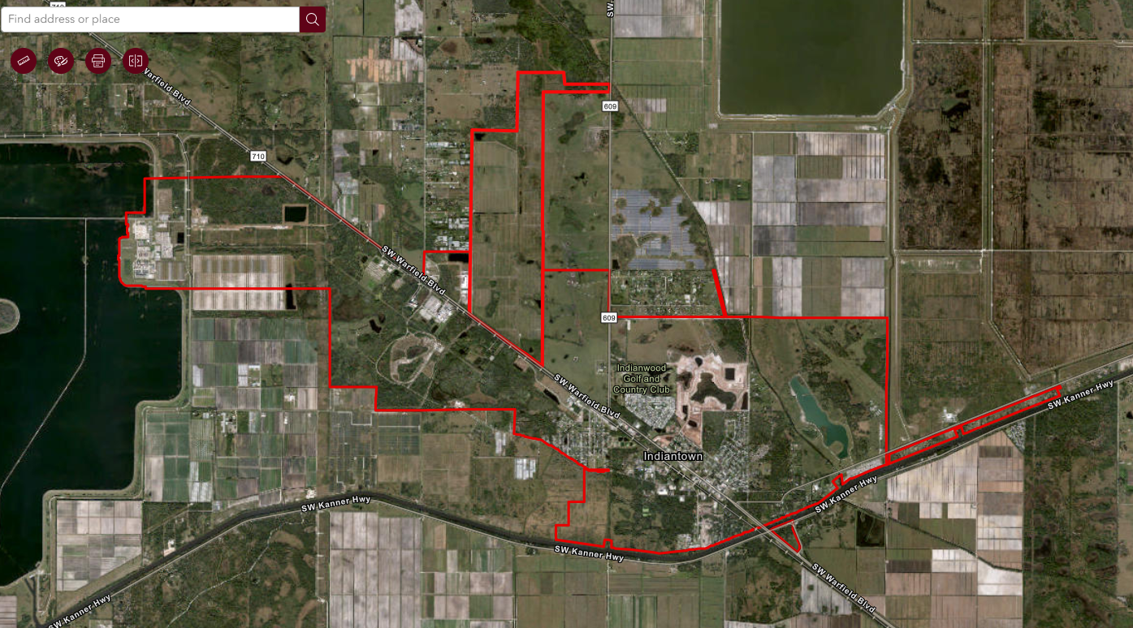

Parcel ID Numbers: Parcel acreages shown below are based on Martin County Property Appraiser records and total approximately 1,288.80 acres. The overall project acreage of ±1,289.71 acres is based on the boundary survey and legal description submitted with the application.

Parcel Number | Acreage | Use Code/Property Classification
25-39-38-000-000-00020-1 | 66.53 | 6300-GrazLD Soil Cpcty CL II
24-39-38-000-000-00030-2 | 180.3 | 6300-GrazLD Soil Cpcty CL II
13-39-38-000-000-00030-5 | 173.9 | 6300-GrazLD Soil Cpcty CL II
25-39-38-000-000-00021-0 | 115.25 | 6300-GrazLD Soil Cpcty CL II
22-39-38-001-001-00220-3 | 18.6 | 6300-GrazLD Soil Cpcty CL II
22-39-38-001-001-00190-9 | 439.59 | 6300-GrazLD Soil Cpcty CL II
22-39-38-001-001-00010-7 | 218.43 | 6300-GrazLD Soil Cpcty CL II
Parcel Number | Acreage | Use Code/Property Classification
36-39-38-001-002-00000-7 | 56.2 | 6300-GrazLD Soil Cpcty CL II
36-39-38-001-001-00000-9 | 20 | 6300-GrazLD Soil Cpcty CL II

Legal Description: Refer to the attached exhibit.

SECTION C: VILLAGE REVIEWERS

The following reviewers, as Development Review Colleagues, have reviewed the request for a voluntary annexation into the Village. At the time the report was completed, all reviewers had completed their reviews and had no outstanding issues requiring a response from the applicant in relation to the applicant’s request.

- Planning & Procedural Reviewer: Deanna Freeman, Community & Economic Development Director 772-597-8269 dfreeman@indiantownfl.gov
- CED Office Coordinator: Lucia Mendoza, 772-597-8299 lmendoza@indiantownfl.gov
- Public Works & Utilities Reviewer: Pat Nolan, Public Works & Utilities Director 772-341-3098 pnolan@indiantownfl.gov
- Village Engineer & Traffic Reviewer: Tom Jensen, P.E., Kimley-Horn, Inc., Village Engineer 561-248-5967 tom.jensen@kimley-horn.com
- Fire Reviewer: Douglas V Killane III, Fire Marshal 772-288-5633 dkillane@martin.fl.us
- Village Surveyor: Ricky Barnes, PSM, Village Surveyor 863-484-8324 Ricky Barnes ricky.barnes@bsmsurvey.com
- Legal Reviewer: Wade Vose, Village Attorney 407-645-3735 ext. 1020 wvose@indiantownfl.gov

SECTION D: APPLICATION THRESHOLDS & MATERIALS SUBMITTED

Review Process and Public Hearing Requirements

Pursuant to Land Development Regulations Chapter 11 – Reviewers and Decisionmakers, the proposed voluntary annexation is subject to the following review process:

- Review and recommendation by staff as the Development Review Colleagues (DRC).

- Public hearing and recommendation by the Planning, Zoning & Appeals Board (PZAB).

- Public hearing before the Village Council on first reading.

- Public hearing before the Village Council on second reading and adoption of the annexation ordinance.
- Recording of the ordinance following adoption, as applicable.

The application is processed in accordance with Chapter 171, Florida Statutes, including Section 171.044, which governs voluntary annexation by petition of property owners.

All required notice procedures have been or will be completed in accordance with the Village Land Development Regulations and Chapter 171, Florida Statutes, including notice to Martin County and required newspaper publication prior to Village Council public hearings.

Application Materials Submittals Include:

- Cover Letter.
- Annexation Application.
- General Development Application.
- Narrative & Justification Statement.
- Survey of Property to be Annexed.
- Description of Surrounding Land Uses & Properties.
- Maps.
- Deeds.
- Legal Descriptions.

SECTION E: LOCATION AND SITE INFORMATION

Parcel Ownership:
The subject property consists of eight contiguous parcels owned by Beskar Investments, LLC, Indiantown North, LLC, Indiantown II North, LLC, Indiantown II Mid, LLC, and Jerry L. Emmert and Nicole L. Emmert, as Trustees of the Jerry L. Emmert and Nicole L. Emmert Living Trust.

Current Use:
The property is currently used for grazing and low-intensity agricultural purposes, with no vertical development, improved roads, or other significant site improvements. The property lies within unincorporated Martin County and is contiguous to the Village boundary on three sides.
Future Land Use & Zoning:

The subject property has a Martin County Future Land Use designation of Agricultural and a Martin County zoning designation of A-2, Agricultural. The applicant has filed a concurrent Large-Scale Future Land Use Map Amendment application requesting that the property be assigned a Village of Indiantown Light Industrial Future Land Use designation upon annexation.
If annexation and the Future Land Use Map amendment are approved, a subsequent rezoning application will be required to establish a zoning district consistent with the adopted Future Land Use designation. The applicant has indicated that a Light Industrial zoning designation or Planned Unit Development (PUD) rezoning request is anticipated.

Current Future Land Use – Martin County: Agricultural
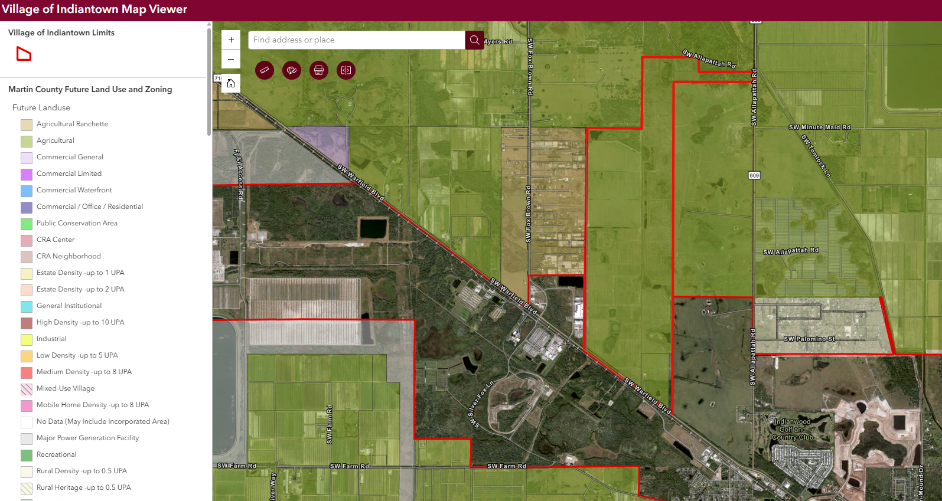

Current Future Land Use Map Village of Indiantown

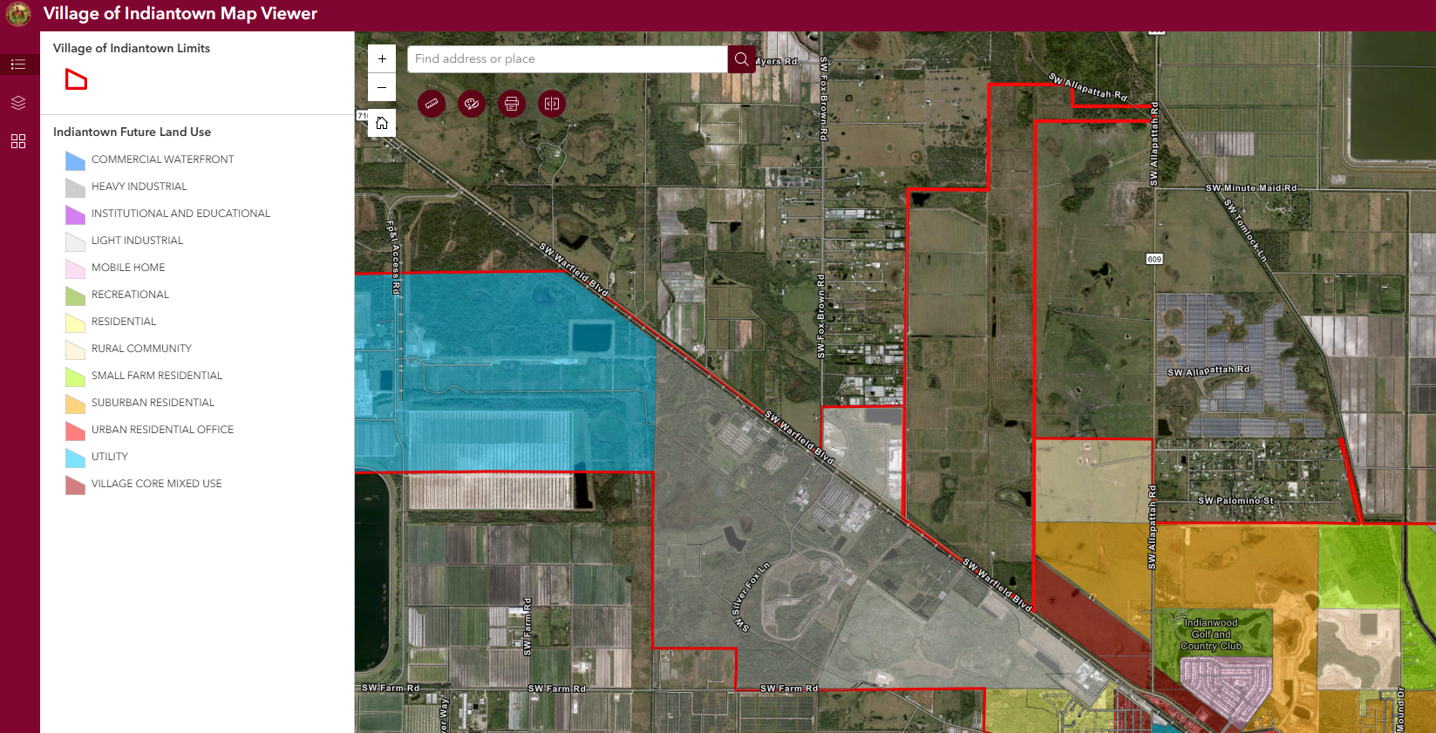

Proposed Future Land Use: Light Industrial

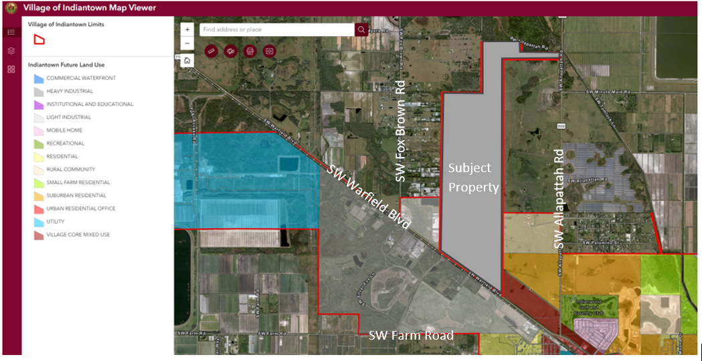

SECTION F: PLANNING ANALYSIS

Planning Analysis

This section evaluates the proposed voluntary annexation for consistency with Chapter 171, Florida Statutes, the Village of Indiantown Comprehensive Plan, and the Village Land Development Regulations.

The subject property is contiguous to the Village of Indiantown municipal boundary, is reasonably compact in configuration, and does not create enclaves, pockets, or irregular boundary patterns.

Contiguity

Section 171.031, Florida Statutes, defines contiguous to mean that a substantial part of the boundary of the territory sought to be annexed is coterminous with a part of the boundary of the annexing municipality.

Staff Review & Analysis:

The subject property consists of eight contiguous parcels located adjacent to the Village boundary on the south, east, and west. The property therefore satisfies the statutory contiguity requirement for voluntary annexation.

Compactness

Section 171.031, Florida Statutes, defines compactness as concentration of property in a single area and precludes annexation patterns that create enclaves, pockets, finger areas, or serpentine configurations.

Staff Review & Analysis:
The subject property is a single, reasonably compact land area. The proposed annexation does not create irregular municipal boundaries, enclaves, pockets, or finger areas. Staff finds the annexation satisfies the statutory compactness standard.

Enclave Considerations

Section 171.031(13), Florida Statutes, defines an enclave as an unincorporated improved or developed area enclosed within and bounded by a municipality, or bounded by a municipality and a natural or manmade obstacle where vehicular access is only through the municipality.

Staff Review & Analysis:

The subject property is not fully surrounded by the Village and therefore does not meet the statutory definition of an enclave. However, the property is bounded on three sides by the Village and is functionally related to Village infrastructure and access patterns. The property is bounded on three sides by the Village and its annexation would further promote logical municipal boundaries and coordinated service delivery consistent with Chapter 171, Florida Statutes.

The proposed voluntary annexation:

- Does not create any new enclaves.

- Does not leave any unincorporated area surrounded by the Village.

- Improves consistency between jurisdictional boundaries, access patterns, and future service delivery.

Accordingly, the annexation is consistent with the policy intent of Chapter 171 to avoid fragmented jurisdictional conditions and promote coordinated planning.

Surrounding Land Use, Zoning & Existing Use

The subject property is currently vacant for development purposes and classified under an agricultural tax exemption in unincorporated Martin County. No vertical development or significant site improvements exist on the property.

The surrounding area includes a mix of agricultural, industrial, and utility-related uses. Lands to the south and west are designated and zoned for Light and Heavy Industrial uses within the Village and include established industrial subdivisions, utility corridors, and employment-generating uses. Lands to the north and portions of the east remain within Martin County jurisdiction and retain Agricultural and other rural-oriented designations.

The following table summarizes the existing Future Land Use, zoning, and current use of properties in proximity to the subject site:

Direction | Future Land Use | Zoning | Existing Use
Site: | Agricultural | A-2, Agricultural  AG-20A Agricultural | Vacant
North: | Agricultural | A-2, Agricultural | FPL Utility &  Vacant agricultural
East: | Agricultural  Rural Community  Suburban Residential  Village Core Mixed Use | A-2, Agricultural | Vacant agricultural
South: | Heavy Industrial  Agricultural  Light Industrial | Heavy Industrial  A-2, Agricultural  Light Industrial | Canal Rights-of-way  CSX Railroad  Florida Natural Gas  Indiantown Commerce & Technology Park
West: | Light Industrial  Agricultural Ranchette | Light Industrial  AR-5A, Agricultural Ranchette  A-2, Agricultural | Venture Park Industrial  Agricultural  Single-family estate

The surrounding land use pattern, particularly to the south and west, demonstrates that the subject property is adjacent to established industrial development and infrastructure corridors. Annexation would place the property within the same jurisdictional framework as adjacent Village lands within an emerging employment corridor.

Approval Evaluation Criteria

This annexation request has been reviewed for consistency with the Village Comprehensive Plan, including Policy IC1.1.25 and Policy IC1.1.26, as well as the procedural requirements of Land Development Regulations Section 12-3 and Chapter 171, Florida Statutes.

Comprehensive Plan Policy IC1.1.25

The Village shall notify Martin County of proposed annexations as required by Chapter 171, Florida Statutes.

Staff Review & Analysis:

Notice to Martin County has been provided in accordance with Chapter 171, Florida Statutes. The application is therefore consistent with Policy IC1.1.25.

Comprehensive Plan Policy IC1.1.26

The Village shall pursue annexation of contiguous lands in unincorporated Martin County, with emphasis on areas that will produce revenue surplus and ensure future fiscal solvency, while unifying the community and improving quality of life.

Staff Review & Analysis:

Staff's finding of consistency with the Comprehensive Plan is limited to the annexation request presently under consideration and should not be interpreted as a determination regarding consistency of any future land use amendment, rezoning request, or development proposal.

The proposed annexation satisfies the intent of Policy IC1.1.26. The property is contiguous to the Village boundary, located within an established access and infrastructure context, and positioned to support coordinated long-term planning within the Village. Annexation would allow the Village to regulate future development through its Comprehensive Plan and Land Development Regulations and would align jurisdictional boundaries with existing and emerging development patterns.

The property is also located adjacent to established industrial lands within the Village. Annexation may support long-term fiscal sustainability by allowing future employment-generating development within the Village, subject to all subsequent land use, rezoning, and infrastructure review requirements.

Accordingly, staff finds that the proposed annexation consistent with Policy IC1.1.26 in that it:

- Involves contiguous property.
- Supports coordinated growth management.
- May contribute to fiscal sustainability.
- Improves consistency in municipal planning and service delivery.

LDR Section 12-3 – Annexation / Contraction Applications

Land Development Regulations Section 12-3 provides that annexation of real property located in an unincorporated area contiguous to the Village shall be processed in accordance with Chapter 171, Florida Statutes.

Staff Review & Analysis:

The proposed voluntary annexation has been reviewed for compliance with Section 12-3 and Chapter 171, including Section 171.044 governing voluntary annexation by petition. Staff find that:

- The subject property is contiguous to the Village boundary.

- The property is reasonably compact.

- The annexation will not create enclaves or irregular municipal boundary patterns.

- Required procedural and notice requirements have been satisfied.

Accordingly, the application complies with Land Development Regulations Section 12-3 and the applicable provisions of Chapter 171, Florida Statutes.

LDR Section 8-2.11 – Mobility Fee Benefit Districts

Section 8-2.11(c) establishes mobility fee benefit districts northeast and southwest of SR-710 and provides that those district boundaries may expand or contract as a result of annexation or de-annexation.

Staff Review & Analysis:

The subject property is located adjacent to SR-710 and, upon annexation, would be incorporated into the applicable mobility fee benefit district consistent with Section 8-2.11(c). This would allow future development on the property to participate in the Village’s mobility fee framework and contribute proportionately toward transportation improvements serving the benefit district.

Accordingly, the proposed annexation is consistent with LDR Section 8-2.11 and supports coordinated transportation planning and funding.

Public Services & Facilities Analysis

The Village of Indiantown functions as an established municipal service environment with access to public utilities, transportation infrastructure, parks, public safety services, and community facilities. Availability of public facilities and services to support future development of the subject property will be evaluated during future rezoning, site plan, and development review processes in accordance with the Village Comprehensive Plan, Land Development Regulations, and concurrency requirements.

Annexation of the property does not itself authorize development or guarantee immediate infrastructure capacity. No development order may be issued unless adequate public facilities are available to maintain adopted levels of service.

Future development shall be subject to concurrency review and shall demonstrate that adequate public facilities and services are available at adopted levels of service at the time development orders are requested.

Water & Sewer

Nothing contained in this annexation approval shall be construed as a guarantee of utility capacity, utility reservations, or service availability. Future service commitments shall be subject to adopted levels of service, infrastructure availability, applicable agreements, and approvals by the Village and other applicable agencies.

The Village owns and operates municipal water and wastewater treatment facilities. Any future development will be required to obtain adequate public facility reservations and demonstrate compliance with applicable level-of-service standards prior to development approval.

The Village has identified potable water capacity constraints and continues to evaluate infrastructure improvements and capital planning measures. Availability of water and wastewater service capacity will be evaluated during future development review processes. No development approvals may be issued without demonstrating adequate public facilities and compliance with adopted level-of-service standards.

Approval of the annexation shall not be construed as a reservation or guarantee of utility capacity or service availability, which shall be evaluated and allocated, if appropriate, through subsequent development review processes and applicable utility agreements.

Drainage & Stormwater Management

Future development will require detailed civil engineering plans addressing drainage, stormwater retention and treatment, finished floor elevations, and floodplain compliance. Stormwater systems must be designed in accordance with Village regulations, South Florida Water Management District requirements, and applicable state standards.

Transportation

The subject property is located along SW Warfield Boulevard (SR-710), an established regional transportation corridor. A traffic study associated with the concurrent land use amendment has been reviewed and accepted by staff. Transportation impacts related to future development will be further evaluated at subsequent stages of development review, and mobility fees, impact fees, and proportionate fair-share obligations will apply as appropriate.

Future traffic impacts, roadway improvements, and proportionate-share obligations shall be evaluated during subsequent development review processes and in coordination with FDOT, Martin County, and other applicable agencies.

Fire Rescue & Emergency Services

Fire rescue services are provided by Martin County pursuant to an interlocal agreement with the Village. This service arrangement will remain in effect following annexation. Future development will be required to comply with all applicable fire code, access, and life safety requirements.

Waste Management, Parks, Schools, Libraries, and Other Services

Because annexation does not itself authorize development, detailed service impacts will be evaluated during subsequent development review. To the extent future industrial development occurs, all applicable concurrency, fee, and service requirements will apply. No residential development is proposed at this time.

Financial Feasibility

Fiscal observations contained herein are intended solely for planning-level analysis and should not be construed as revenue projections or guarantees. Actual fiscal impacts are dependent upon future market conditions, development approvals, taxable values, infrastructure costs, and other factors not presently known.

A financial feasibility review was conducted to evaluate the fiscal implications of annexation and future development of the subject property. The property currently generates minimal ad valorem revenue. If annexed and later developed consistent with Village land use and zoning approvals, taxable value is anticipated to increase substantially.

For planning-level analysis, a conservative land value estimate of $45,000 per acre was applied. At approximately ±1,289.71 acres, this equates to an estimated taxable value of approximately $58,037,000. Applying the Village’s current millage rate of 1.8250 mills results in projected annual ad valorem revenue of approximately $105,843, exclusive of additional taxable value associated with buildings, site improvements, and equipment.

Future development may also generate additional revenues, including:

- Mobility and impact fees.

- Utility connection fees and ERCs.

- Proportionate fair-share contributions, if required.

- Business tax receipts.

- Permit and inspection fees.

Based on available fiscal analysis, annexation and future development of the property have the potential to create a positive fiscal impact over time, subject to future development approvals and market conditions.

Annexation Agreement Consideration

Staff Review & Analysis:

The Village Council may consider provisions addressing infrastructure timing, transportation improvements, utility availability, employment-generating uses, buffering, development phasing, and other matters deemed appropriate in furtherance of the public health, safety, and welfare.

Given the scale of the proposed annexation and the long-term development potential of the ±1,289.71-acre property, the Village Council may wish to consider whether an annexation agreement should accompany the annexation approval. An annexation agreement may establish provisions related to infrastructure coordination, development phasing, transportation improvements, utility service expectations, permitted or restricted uses, and other obligations determined appropriate by the Village Council.

The use of an annexation agreement may assist the Village in ensuring that future development occurs in a coordinated manner consistent with the Village Comprehensive Plan, Land Development Regulations, and long-term infrastructure planning objectives. Such an agreement would not replace the Village’s development review process and would not supersede requirements related to concurrency, rezoning, site plan approval, or applicable state and regional permitting.

Planning Record Clarification

Approval of the annexation does not create vested rights and does not preclude the Village from imposing additional conditions or requirements through subsequent land use, zoning, development agreement, site plan, concurrency, permitting, or other applicable review processes.

The analysis contained in this staff report evaluates the proposed annexation for general consistency with Chapter 171, Florida Statutes, the Village Comprehensive Plan, and applicable Land Development Regulations. The findings are based on currently available information and planning-level analysis appropriate for annexation review. Approval of the annexation does not authorize development of the subject property. Any future development will require separate approvals, including a Future Land Use Map amendment, rezoning, site plan review, concurrency evaluation, and compliance with all applicable local, regional, and state requirements.

The proposed annexation represents only one component of a multi-step planning and regulatory process. Annexation, future land use amendment, rezoning, development agreements, site plan approval, concurrency determinations, and permitting are separate actions, each requiring independent review and approval based upon the record established for that application.

Effect of Annexation

Approval of the proposed voluntary annexation is limited to the incorporation of the subject property into the municipal boundaries of the Village of Indiantown and does not constitute approval of any specific development proposal, land use entitlement, zoning classification, density, intensity, site plan, utility reservation, or development order.

Any future development of the property shall remain subject to separate applications and approvals, including but not limited to Future Land Use Map amendments, rezoning, development agreements, site plan approval, concurrency review, and all applicable local, regional, state, and federal permitting requirements.

Each subsequent application shall be reviewed independently based upon the record established for that application and in accordance with applicable laws, regulations, and adopted policies.

Governmental Discretion and No Vested Rights

Approval of the annexation does not create vested rights or establish any entitlement to future approvals. Nothing contained in this staff report, or any annexation approval, shall be interpreted as obligating the Village to approve any future land use amendment, rezoning request, development agreement, site plan, permit, or other development approval affecting the property.
Nothing contained herein shall limit, impair, or otherwise restrict the legislative or quasi-judicial discretion of the Village Council, Planning, Zoning and Appeals Board, or any other reviewing authority with respect to future applications involving the subject property.

Future applications shall be considered upon their own merits and based upon the applicable standards, evidence, and record established at the time such applications are presented.

Planning Record Clarification

The analysis contained in this staff report is intended solely to evaluate the proposed annexation for general consistency with Chapter 171, Florida Statutes, the Village Comprehensive Plan, and applicable provisions of the Village Land Development Regulations.

The findings contained herein are based upon currently available information and constitute planning-level analysis appropriate to annexation review. Findings of consistency contained in this report are limited to the annexation request presently under consideration and shall not be construed as findings regarding the consistency, appropriateness, or approval of any future land use amendment, rezoning application, development agreement, site plan, or development proposal.

The proposed annexation represents only one component of a multi-step planning and regulatory process. Annexation, future land use amendments, rezoning, development agreements, site plan approvals, concurrency determinations, and permitting are separate actions, each requiring independent review and approval based upon the record established for that application.

Approval of the annexation does not authorize development of the subject property and does not guarantee the availability of public facilities, utility capacity, transportation improvements, or any specific governmental approval. No development order may be issued unless adequate public facilities are available and adopted level-of-service standards are maintained.
Nothing contained in this report shall be construed as a commitment by the Village to provide utility service, approve future development, or waive any requirement imposed by applicable local, regional, state, or federal regulations.

SECTION G: CONCLUSION & RECOMMENDATION

Overall Staff Findings

The proposed voluntary annexation of approximately ±1,289.71 acres is generally consistent with the applicable provisions of Chapter 171, Florida Statutes, the Village Comprehensive Plan, and the Village Land Development Regulations.

The subject property is contiguous to the Village boundary on three sides, reasonably compact in configuration, and the proposed annexation does not create enclaves or irregular municipal boundaries. The annexation would improve consistency between jurisdictional boundaries, infrastructure access, and long-term growth management planning.

The subject property is also located adjacent to existing and planned industrial and employment-related land uses within the Village. Annexation would place the property within the Village’s jurisdictional and regulatory framework, allowing future development to be evaluated in a coordinated manner consistent with Village planning policies, concurrency requirements, and infrastructure planning efforts.
Staff Recommendation

Based on the analysis contained in this staff report, Village staff finds that the proposed voluntary annexation:

- It is consistent with Chapter 171, Florida Statutes.

- Satisfies applicable Village Land Development Regulations.

- Involves contiguous and reasonably compact property.

- Does not create enclaves or irregular municipal boundary patterns.

- Supports orderly municipal boundary expansion.

- Improves coordinated planning and service delivery.

- May support long-term fiscal sustainability.

Based upon the foregoing findings and analysis, staff finds Application ANX 24-072 generally consistent with Chapter 171, Florida Statutes, the Village Comprehensive Plan, and the Village Land Development Regulations. Accordingly, staff recommends that the Planning, Zoning and Appeals Board recommend approval of Application ANX 24-072 – Beskar Voluntary Annexation to the Village Council. Staff further recommends that the Village Council consider the use of an annexation agreement to address infrastructure coordination, development timing, service expectations, and other obligations associated with future development of the property.

Planning, Zoning & Appeals Board (PZAB) Recommendation as Local Planning Agency: TBD

Village Council Decision – First Reading: TBD

Village Council Decision – Second Reading: TBD

