
Village of Indiantown
Planning, Zoning & Appeals Board
Staff Report

Application Number CPA Comprehensive Plan Amendment

Hearing Date April 2, 2026

Property Owner/
Applicant

Applicant Tyson Waters, Esq.
Representative Fox McCluskey,
3461 SE Willoughby Blvd.
Stuart, FL 34994

Village Coordinator Deanna Freeman,
Community & Economic Development Director

Village Reviewers Deanna Freeman,
Community & Economic Development Director
Tom Jensen, P.E., Kimley-Horn, Inc.
Patrick Nolan, Public Works & Utilities Director
Wade Vose, Village Attorney
Applicant Request

Application No. CPA 24-009, REQUEST FOR APPROVAL OF A LARGE-SCALE COMPREHENSIVE PLAN AMENDMENT (CPA) OF THREE CONTIGUOS PARCELS OF LAND FOR APPROXIMATELY 116.16-ACRES OF LAND LOCATED SOUTH OF SW CITRUS BOULEVARD, NORTH OF SW KANNER HIGHWAY, AND IMMEDIATELY EAST OF THE EXISTING BOUNDARIES OF THE VILLAGE OF INDIANTOWN.

Joseph w. Walsh & Indiantown Property Holdings, LLC, (“Applicant”) are seeking a recommendation of approval for a Large-scale Comprehensive Plan Amendment (CPA) pursuant to Land Development Regulation Sec. 12-4. – Comprehensive Plan text and map amendment applications and F.S. §§ 163.3184. A concurrent request for a voluntary annexation was approved by the Village Council on March 28, 2024. A concurrent request to rezone the property is included as a separate staff report, draft Ordinance, and agenda item.

Property Information

Location: The approximately 116.16-acre subject property is located south of SW Citrus Boulevard, north of SW Kanner Highway, and immediately east of the existing boundaries of the Village of Indiantown.

Location Map:

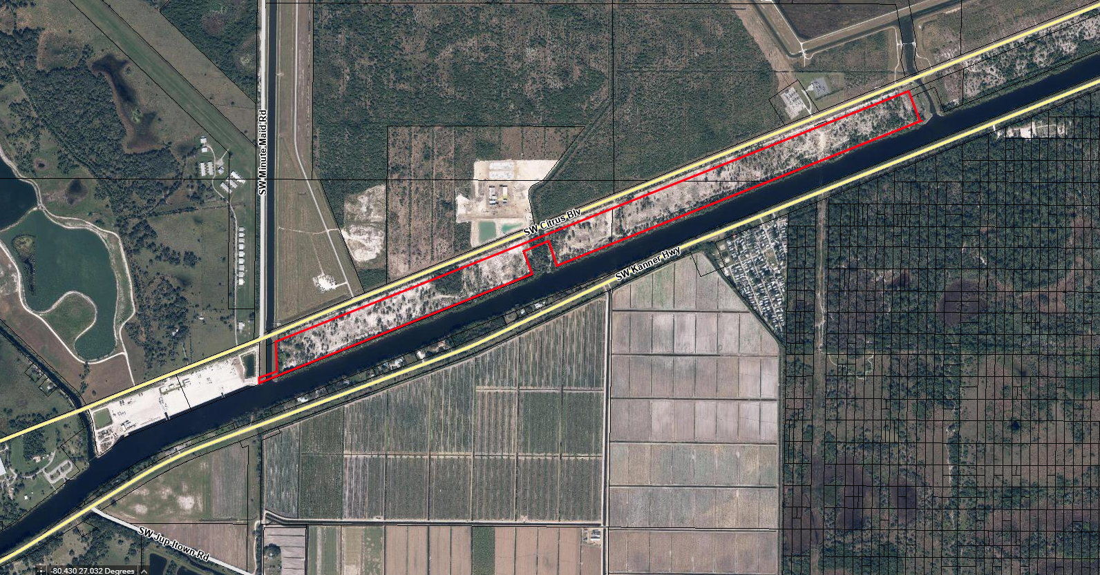

Parcel ID Numbers: 03-40-39-000-000-00030-2
02-40-39-000-000-00050-9
35-39-39-000-000-00040-4
Legal Description:

PARCEL 1:
A PARCEL OF LAND LYING IN SECTION 2 AND 3, TOWNSHIP 40 SOUTH, RANGE 39 EAST, AND LYING IN SECTION 35, TOWNSHIP 39 SOUTH, RANGE 39 EAST, MARTIN COUNTY, FLORIDA, AND BEING MORE PARTICULARLY DESCRIBED AS FOLLOWS:

BEGINNING AT A POINT ON THE NORTHERLY RIGHT OF WAY LINE OF ST. LUCIE CANAL AS SHOWN ON RIGHT OF WAY MAP RECORDED IN PLAT BOOK 10, PAGE 84, PUBLIC RECORDS OF MARTIN COUNTY, FLORIDA, SAID POINT LYING 60.00 FEET EAST OF THE WEST LINE OF SECTION 3, TOWNSHIP 40 SOUTH, RANGE 39 EAST, AS MEASURED AT RIGHT ANGLES; THENCE NORTH 00°39'38" WEST ALONG A LINE 60.00 FEET EAST OF AND PARALLEL WITH SAID WEST LINE OF SECTION 3, AS MEASURED AT RIGHT ANGLES, A DISTANCE OF 80.44 FEET TO THE SOUTHERLY LINE OF A PARCEL HAVING IDENTIFICATION NUMBER 03-40-39-000-000-00031-0 AS RECORDED IN OFFICIAL RECORDS BOOK 3379, PAGE 2923, SAID SOUTHERLY LINE BEING 75.00 FEET NORTHERLY OF AND PARALLEL WITH THE NORTH LINE OF SAID ST. LUCIE CANAL; THENCE NORTH 68°08'53" EAST ALONG SAID SOUTHERLY LINE OF SAID PARCEL, A DISTANCE OF 160.88 FEET TO A POINT ON THE EAST LINE OF A 150 FOOT EASEMENT RECORDED IN OFFICIAL RECORDS BOOK 170, PAGE 33, ALSO SAID LINE BEING 210.00 FEET EAST OF AND PARALLEL WITH THE WEST LINE OF SAID SECTION 3, AS MEASURED AT RIGHT ANGLES, ALSO SAID LINE BEING THE EASTERLY LINE OF SAID PARCEL 03-40-39-000-000-00031-0; THENCE NORTH 00°39'38" WEST ALONG SAID LINE, A DISTANCE OF 325.88 FEET TO A POINT; THENCE CONTINUE ALONG SAID LINE NORTH 00°17'57" EAST, A DISTANCE OF 130.86 FEET TO A POINT ON THE SOUTHERLY RIGHT OF WAY LINE OF COUNTY ROAD 726, ALSO KNOWN AS SW CITRUS BOULEVARD, (A VARIABLE WIDTH RIGHT OF WAY), AS SHOWN IN PLAT BOOK 9, PAGE 6, PUBLIC RECORDS OF MARTN COUNTY, FLORIDA, SAID LINE LYING 500.00 FEET NORTHERLY OF THE NORTH RIGHT OF WAY OF SAID ST. LUCIE CANAL, AS MEASURED AT RIGHT ANGLES; THENCE NORTH 68°08'53" EAST ALONG SAID SOUTHERLY RIGHT OF WAY LINE OF SW CITRUS BOULEVARD, A DISTANCE OF 8783.02 FEET TO A POINT ON THE WESTERLY LINE OF A 185 FOOT WIDE FLORIDA POWER AND LIGHT EASEMENT RECORDED IN DEED BOOK 97, PAGE 180; THENCE NORTH 34°24'47" WEST ALONG THE WESTERLY LINE OF SAID EASEMENT A DISTANCE OF 30.74 FEET TO A POINT, SAID POINT LYING 70.00 FEET SOUTHERLY OF THE BASELINE OF SURVEY OF SECTION 890503-2601, CITRUS BOULEVARD, AS SHOWN ON THE STATE OF FLORIDA RIGHT OF WAY MAP RECORDED IN PLAT BOOK 9, PAGE 6; THENCE NORTH 68°08'53" EAST ALONG A LINE PARALLEL WITH AND 70.00 FEET SOUTHERLY OF SAID BASELINE OF SURVEY, A DISTANCE OF 189.54 FEET TO A POINT ON THE EASTERLY LINE OF SAID FLORIDA POWER ANO LIGHT EASEMENT; THENCE SOUTH 34°24'47" EAST ALONG SAID FLORIDA POWER AND LIGHT EASEMENT, A DISTANCE OF 30.74 FEET TO A POINT ON THE SOUTHERLY RIGHT OF WAY LINE OF SAID SW CITRUS BOULEVARD; THENCE NORTH 68°08'53" EAST ALONG THE SOUTHERLY RIGHT OF WAY LINE OF SAID SW CITRUS BOULEVARD, A DISTANCE OF 1417.15 FEET TO A POINT, SAID POINT BEING ON THE WESTERLY LINE OF EASEMENT "NO. 4" RECORDED IN OFFICIAL RECORDS BOOK 170, PAGE 33; THENCE SOUTH 27°58'17" EAST ALONG SAID EASEMENT "N0.4", A DISTANCE OF 103.05 FEET TO A POINT, SAID POINT BEING THE INTERSECTION OF THE NORTHERLY LINE OF PARCEL "NO.833" RECORDED IN PLAT BOOK 10, PAGE 84, AND THE WESTERLY LINE OF SAID EASEMENT "NO.4"; THENCE SOUTH 68°09'54" WEST ALONG THE NORTHERLY LINE OF SAID PARCEL "NO.833", A DISTANCE OF 120.80 FEET TO A POINT ON THE WESTERLY LINE OF SAID PARCEL "NO.833"; THENCE SOUTH 21°51'07" EAST ALONG THE WESTERLY LINE OF SAID PARCEL "NO.833", A DISTANCE OF 397.57 FEET TO A POINT ON THE NORTHERLY RIGHT OF WAY LINE OF SAID ST. LUCIE CANAL; THENCE SOUTH 68°08'53" WEST ALONG SAID NORTHERLY RIGHT OF WAY LINE OF ST. LUCIE CANAL, A DISTANCE OF 5898.67 FEET TO A POINT ON THE EASTERLY LINE OF PARCEL "NO.826" AS SHOWN ON SAID ST. LUCIE CANAL RIGHT OF WAY MAP; THENCE NORTH 21°50'57" WEST A DISTANCE OF 398.43 FEET TO A POINT ON THE NORTHERLY LINE OF SAID PARCEL "NO.826"; THENCE SOUTH 68°09'03" WEST, A DISTANCE OF 399.62 FEET TO A POINT ON THE WESTERLY LINE OF SAID PARCEL "NO.826"; THENCE SOUTH 21°50'57" EAST. A DISTANCE OF 398.45 FEET TO A POINT ON THE NORTHERLY RIGHT OF WAY LINE SAID ST. LUCIE CANAL; THENCE SOUTH 68°08'53" WEST ALONG SAID RIGHT OF WAY LINE, A DISTANCE OF 4338.67 FEET TO THE POINT OF BEGINNING.

CONTAINING 5,059,780 +/- SQ.FT. (116.16 +/- ACRES)
Background: The application was received for completeness review determination by the Village November 16, 2023, deemed complete November 20, 2023. This request requires review and recommendation by the Development Review Colleagues (DRC), a recommendation by the PZAB as a public hearing, and the review and decision making by the Village Council at two separate public hearings ahead of the draft Ordinance being signed and recorded. Prior to the second Village Council public hearing consultation comments are requested from reviewing agencies. Within 10 working days after 2nd Village Council public hearing transmit to the State. The State responds with comments ahead of the amendment becoming effective.

The application has been noticed in accordance with the provisions and requirements of 2023 Florida Statutes Chapter 171.044.

Application Materials Submittals Include:

- Comprehensive Plan Amendment Application.
- Development application.
- Boundary Surveys.
- Narrative & Justification Statement.
- Description of Surrounding Properties & Uses.
- Maps.
- Deeds.
- Legal Description.
- Narrative.
- Traffic Analysis.
- Exhibits.

Subject Property Parcel Size: 116.16-acres +/-

Parcel Ownership: The property is owned by Joseph w. Walsh & Indiantown Property Holdings, LLC as joint applicants for the Large-scale comprehensive plan amendment (CPA) for three contiguous parcels.

Current Use: The property is vacant, with no building structures, improved roads or other developed features located on the site.

Municipal Boundary Map:

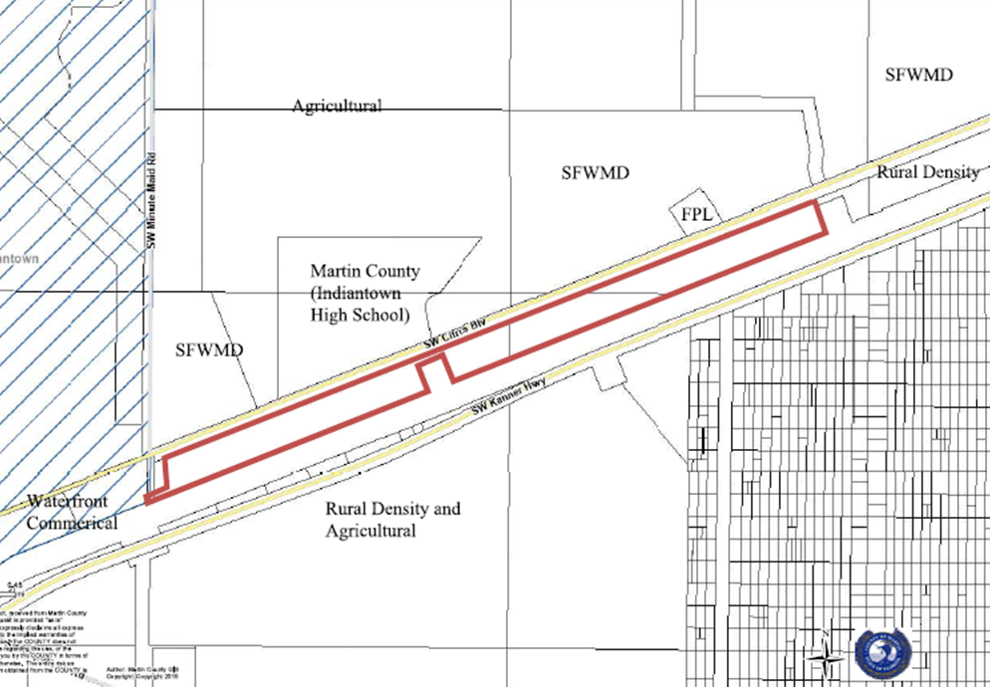

Future Land Use & Zoning
The subject property has a Martin County Future Land Use designation of Rural Density and a zoning district designation of A-2, Agriculture. The current land use and zoning district designation are inconsistent. Any development on the vacant subject property triggering a development application would require a mandatory rezoning from A-2, Agriculture to RE-2A, Rural Estate District, consistent with the Rural Density Future Land Use designation. The applicant is requesting a Voluntary Annexation into the Village of Indiantown, and a concurrent Large-Scale future land use amendment to Commercial Waterfront, consistent with property west of the subject property. A request to change the zoning from A-2, Agriculture to Canal Mixed Use zoning district is consistent with the proposed future land use map amendment and voluntary annexation.

Current Future Land Use Martin County: Rural Density

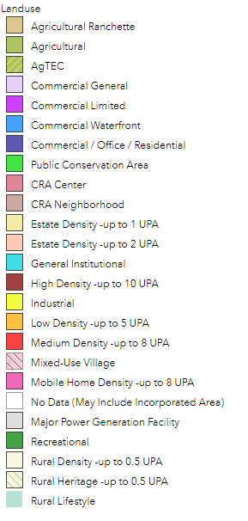
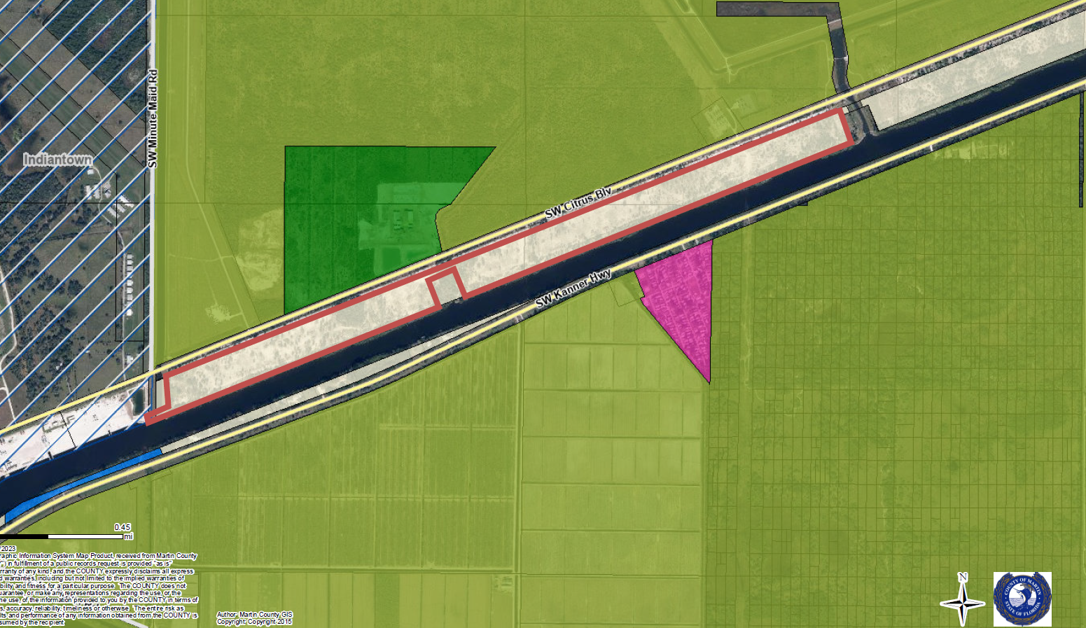

Current Future Land Use Map Village of Indiantown

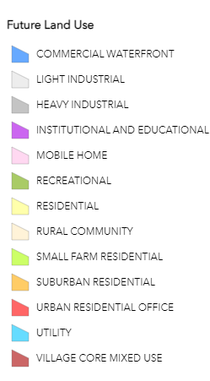
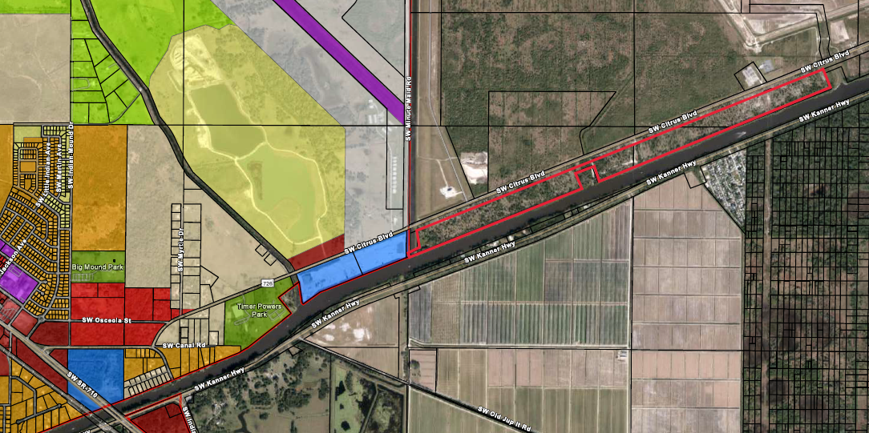

Proposed Future Land Use: Commercial Waterfront

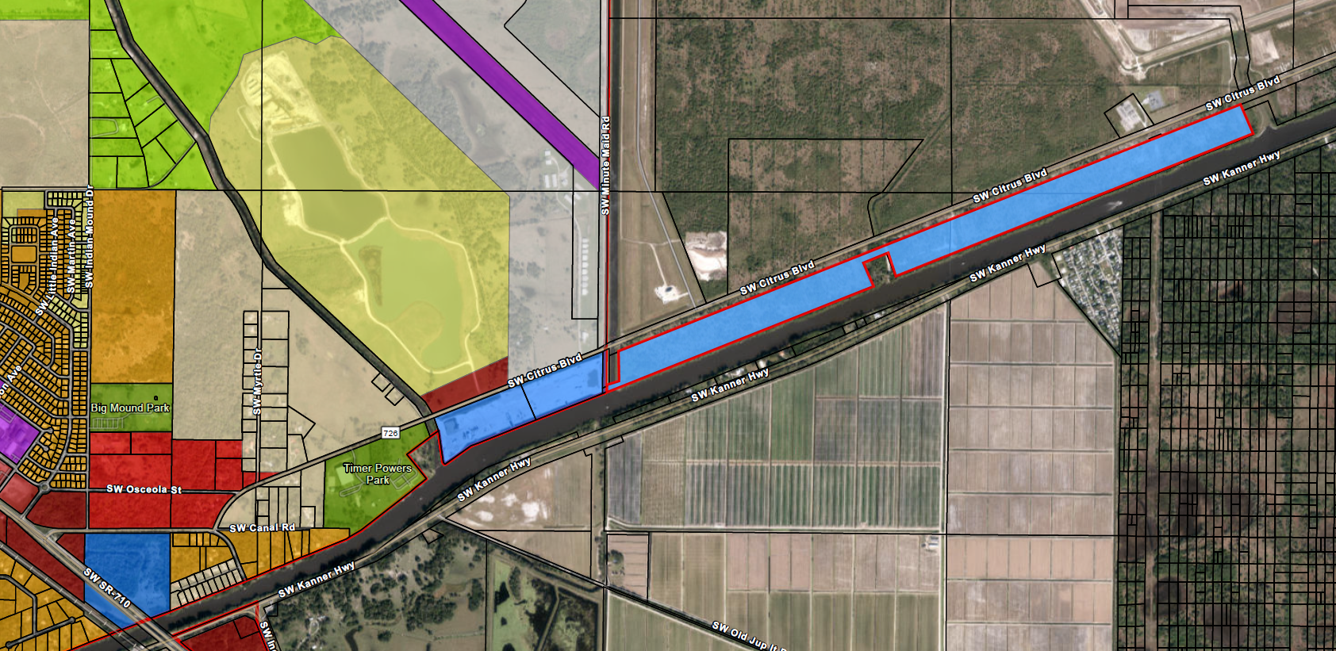

Staff Analysis

Surrounding Land Use, Zoning & Existing Use:

An overview of established development patterns within proximity to the subject property includes lands immediately south having been developed to accommodate the newly constructed Indiantown High School, located on the south side of SW Citrus Boulevard.

To the west is the Village of Indiantown municipal boundary with property contiguous and abutting the subject property. Lands to the immediate west consist of the established Indiantown Marine Services facility, located on a 38 +/- acre property offering servicing and storage of vessels, daily dockage, workspace, and storage space at the existing facility.

Northwest of the Indiantown Marine Center property includes the Indiantown Airport, property with multiple storage hangars associated with the airport, and vacant lands with a Village Mixed Use land use and zoning district. Further north, on the opposite side of SW Citrus Boulevard, lands are owned by South Florida Water Management District and recreational lands owned by Martin County.

South of the subject property is the St. Lucie Canal with residential and agricultural lots on the opposite side of the canal as unincorporated Martin County lands. East of the subject property there are several vacant lots within unincorporated Martin County. While southeast of the subject property, across the St. Lucie Canal is the existing 30-acre +/- St Lucie Village Mobile Home Park.

The following table provides a more detailed breakdown of existing use, land use and zoning of properties within proximity to the subject property.
Direction | Future Land Use | Zoning | Existing Use
Site: | Rural Density | A-2 | Vacant
North: | Agricultural  Recreational  Agricultural | A-2  PR  A-2 | SFWMD lands – Agricultural  Indiantown Highschool  FP&L
East: | Rural Density |  | Vacant lands
South: | St. Lucie Canal  Commercial Waterfront  Rural Density  Mobile Home  Agricultural | St. Lucie Canal  WGC  A-2  TP  A-2 | St. Lucie Canal  St. Lucie Canal Corp, Warehouse Distribution Terminal  Single family homes  St Lucie Village Mobile Homes  Vacant/cropland
West: | Rural Density  Commercial  Waterfront | A-2  Canal Mixed Use | SFWMD - Water  Indiantown Marine Services

Current Zoning Martin County: A-2, Agricultural

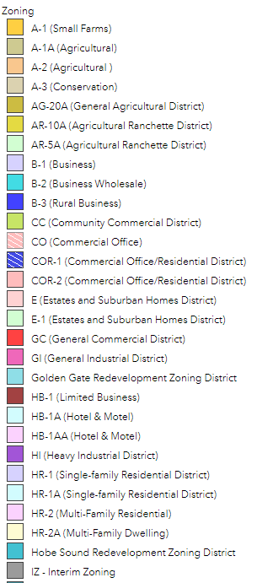
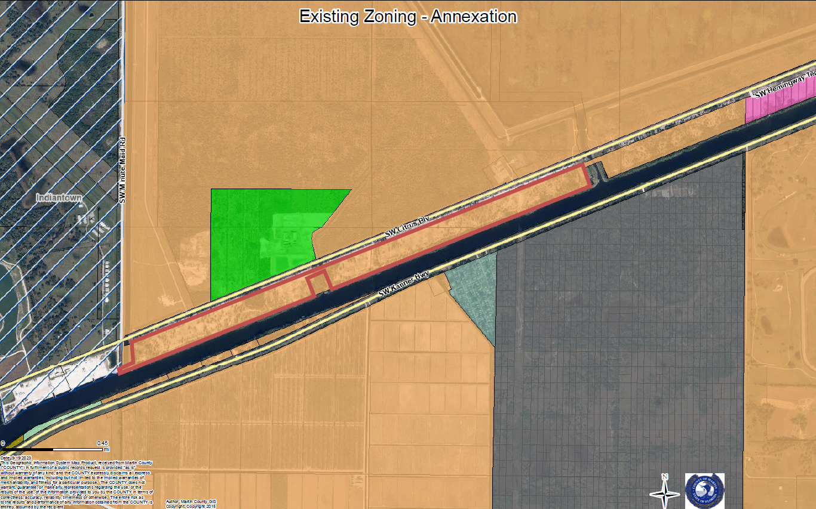

Current Zoning Map Village of Indiantown

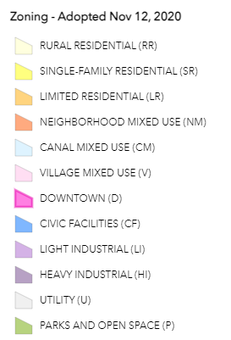
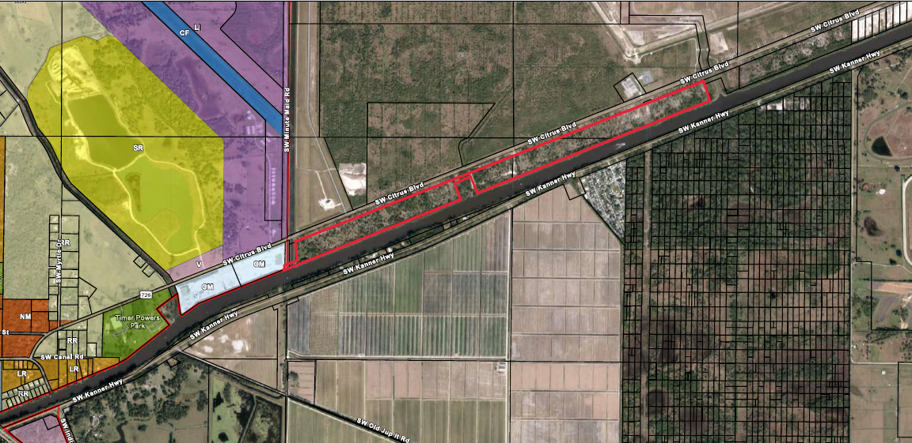

Proposed Zoning: Canal Mixed Use

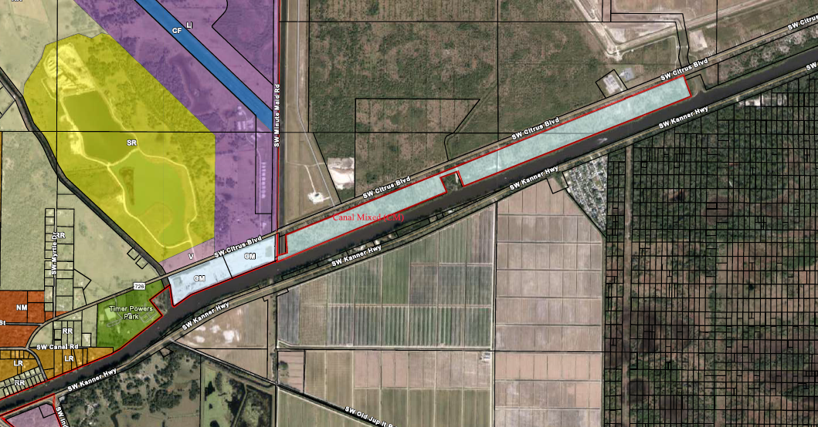

Public services and facilities will be available to serve the needs of the subject properties. The newly constructed Indiantown High School, located north of SW Citrus Blvd and the subject property, is well served by existing public infrastructure, including provision of a 12’ watermain and 6’ force main piping to accommodate water and sewer provisions. SW Citrus Boulevard abuts the property, as a minor arterial road while SW Kanner Highway, a major arterial roadway, is further south of the St. Lucie Canal, demonstrating established roadway infrastructure is in place.

Environmental Considerations

Wetlands, soils, and hydrology

The soils on the subject property are 53—Udorthents, 0 to 35 percent slopes
according to Martin County Maps, and South Florida Water Management District (SFWMD). 53—Udorthents, 0 to 35 percent slopes have no Hydric soil rating. SFWMD Categorization of County Soil Survey Data within SFWMD Including Natural Soils Landscape Positions, (NSLP) provides a description of the classification of the Soil Survey Geographical Data Base (SSURGON) for NSLP #11 Urban or Made Lands. This is described by SFWMD as Urban or made land areas have been altered, excavated, or disturbed and no longer have their natural morphological soil features. These soils no longer function as they did in their original state, so there is little information available. The seasonal high-water table varies by site and is usually controlled to inhibit flooding of developed areas. Common soils of this landscape position include Arents, Matlacha, Pits, Udorthents, and Urban Land.

Wellfield Protection: The property is not within or near a wellfield protection zone.

The Martin County GIS mapping system identifies a potential National Wetland Inventory area along the western boundary of the subject property, directly adjacent to the eastern edge of the Village of Indiantown boundary. Any development of the subject property will require detailed environmental assessment and protection of existing wetlands in accordance with the provisions of SFWMD and DEP.

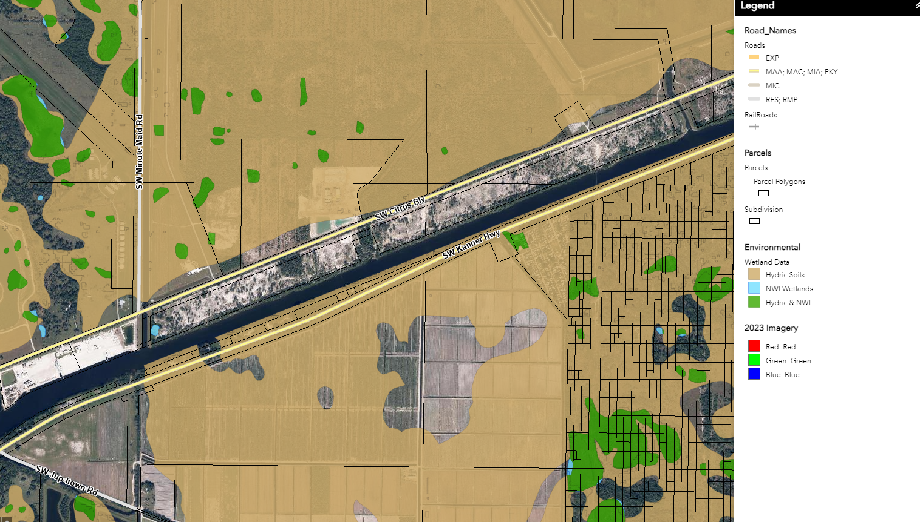

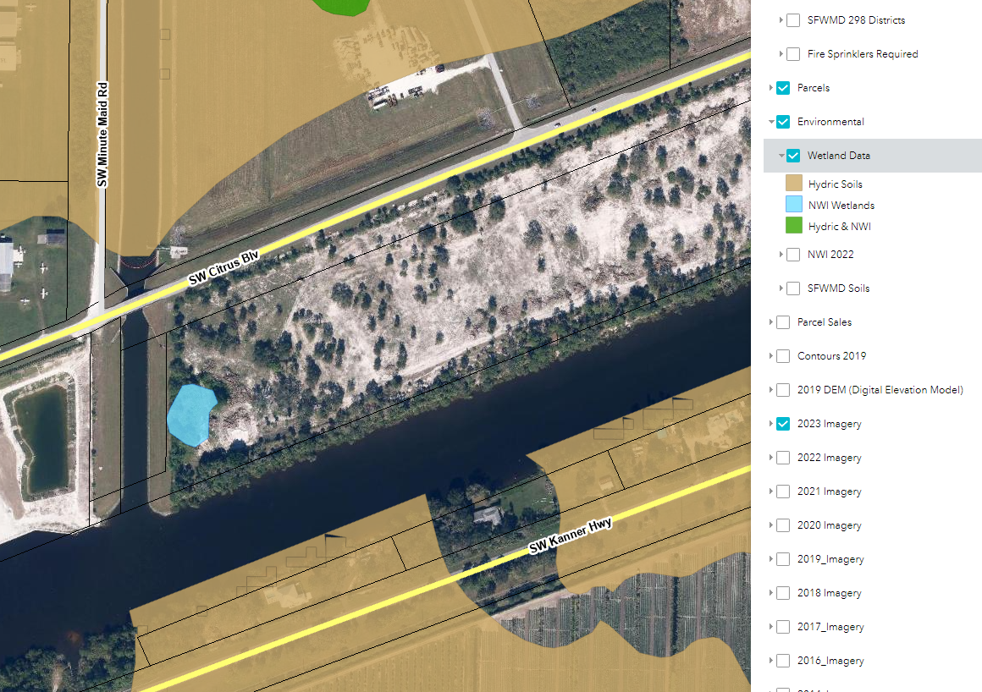
Approval Evaluation Criteria

This application was reviewed for compliance with the Village Land Development Regulations (LDRs). Submittal requirements for a Comprehensive Plan map amendment are included in Sec. 12-4. (3). The Applicant has satisfied the requirements of the LDR provisions. Pursuant to Sec. 12-4. – Comprehensive Plan text and map amendments and subsection (4) Procedure and Florida State Statue F.S. §§ 163.3184 as a Large-scale comprehensive plan amendment.

Why is the proposed change to the FLUM needed?

The subject property has a Martin County Future Land Use designation of Rural Density and a zoning district designation of A-2, Agriculture. The current land use and zoning district designation are inconsistent. Any development on the vacant subject property triggering a development application requires a mandatory rezoning from A-2, Agriculture to RE-2A, Rural Estate District, consistent with the Rural Density Future Land Use designation. The applicant is requesting a Large-Scale future land use amendment to Commercial Waterfront, consistent with property to the east of the subject property. A request to change the zoning from A-2, Agriculture to Canal Mixed Use zoning district is consistent with the proposed future land use map amendment and voluntary annexation.

Analysis & Review of Comprehensive Plan Policies

Comprehensive Plan OBJECTIVE L1.1 PLANNING LAND FOR THE VILLAGE VISION
The Village of Indiantown Comprehensive Plan shall protect and enhance the quality of life and include policies to capitalize on existing infrastructure, discourage a sprawl development pattern and provide educational, cultural, recreational, commercial, industrial and employment opportunities for the citizens.

Staff Review & Analysis: The request has been reviewed against the Comprehensive Plan Policy L1.2.3 Discourage Urban Sprawl Through Amendments with detailed responses to address each of the discouragement of the proliferation of urban sprawl through amendments.

Regarding protecting and enhancing the quality of life, the request to amend the future land use to Commercial Waterfront will provide for variety of marina and water-related uses and services including, but not limited to, commercial docking, boat slips and launches, marine equipment and boat sales, resorts, restaurants, shops, and more intense marine services such as boat repair and construction. The subject property is located along accessible waterfront sites with the potential to satisfy the unique location, market, and resource needs of water-dependent, marine service/industrial uses. Furthering opportunities for the Village of Indiantown to accommodate economic growth and opportunities and expand on existing water-based activities with potential elements including provision of educational, cultural, recreational and waterfront based commercial, industrial and employment opportunities for the community and applicable industries.

Comprehensive Plan Policy L1.2.2 - Future Land Use Mapping Compatibility with Surrounding Lands The adopted Future Land Use Map and any amendments will be appropriate to the location, access, and surrounding land use.

Staff Review & Analysis: The approximately 116.16-acre subject property is located south of SW Citrus Boulevard abutting the property, as a minor arterial road. While SW Kanner Highway, as a major arterial roadway, is further south of the St. Lucie Canal. Immediately east of the existing boundaries of the Village of Indiantown. Vehicular access to the property would be accommodated off SW Citrus Boulevard while the properties’ location on the St. Lucie Canal, provides an opportunity for deep water access to both coasts of Florida as an accessible waterfront. To the immediate west of the subject property are lands designated with the proposed future land use, Commercial Waterfront, and marine industrial operations are already established. The recently developed Indiantown Highschool is also located to the north of the subject property.

Comprehensive Plan Policy L1.2.5 Development Orders and Level of Service
Before a development order or permit is issued, the Village of Indiantown shall seek to ensure that the adopted level of service standards for the affected public facilities will be maintained in accordance with the established concurrency management system defined in the Comprehensive Plan and Land Development Regulations.

Staff Review & Analysis: Levels of service and an adequate public facilities reservation will be required as part of the application submission and review by the Village’s Development Review Colleagues prior to approval of a site plan for the subject property. Infrastructure is already in place and serving the newly constructed Indiantown Highschool to the north of the subject property.

Section 163.3177(6)(a)9., Florida Statutes, states the future land use element and any amendment to the future land use element shall discourage the proliferation of urban sprawl. The primary indicators that a plan or plan amendment does not discourage the proliferation of urban sprawl are listed below. The evaluation of the presence of these indicators shall consist of an analysis of the plan or plan amendment within the context of features and characteristics unique to each locality in order to determine whether the plan or plan amendment:
(I) Promotes, allows, or designates for development substantial areas of the jurisdiction to develop as low-intensity, low-density, or single-use development or uses.
No. The request to amend the future land use to Commercial Waterfront will provide for variety of marina and water-related uses and services including, but not limited to, commercial docking, boat slips and launches, marine equipment and boat sales, resorts, restaurants, shops, and more intense marine services such as boat repair and construction.
(II) Promotes, allows, or designates significant amounts of urban development to occur in rural areas at substantial distances from existing urban areas while not using undeveloped lands that are available and suitable for development.
No. The subject property is proposed to be located within the municipal boundary of the Village of Indiantown with the proposed Commercial Waterfront land use designation being consistent with existing land use designations immediately abutting the subject property to the east, offering an expansion and continuation of marine based activities on lands with waterfront location where urban services are available within proximity to the site.
(III) Promotes, allows, or designates urban development in radial, strip, isolated, or ribbon patterns generally emanating from existing urban developments.
No. The location of the subject property offers a continuation of established development patterns to the east of the subject property. The property is not isolated and will not create a ribbon pattern of radial strip of development. General development patterns include a mix of land uses as per the detailed breakdown included in the staff report and include the newly constructed Indiantown Highschool to the north and an established industrial marina to the west.
(IV) Fails to adequately protect and conserve natural resources, such as wetlands, floodplains, native vegetation, environmentally sensitive areas, natural groundwater aquifer recharge areas, lakes, rivers, shorelines, beaches, bays, estuarine systems, and other significant natural systems.
No. Any protection measures required will be in accordance with Comprehensive Plan Policies, Land Development Regulations and third-party reviews included SFWMD and FDEP. The proposed land use amendment will not impact any wetlands or environmentally sensitive areas, lakes, rivers, shorelines, beaches, bays estuarine systems or other nature systems. The subject site is not located within a wellfield projection zone.
(V) Fails to adequately protect adjacent agricultural areas and activities, including silviculture, active agricultural and silvicultural activities, passive agricultural activities, and dormant, unique, and prime farmlands and soils.
No. Adjacent agricultural areas or activities will not be impacted by the proposed land use amendment. Existing lands to the north, owned by SFWMD and Martin County will continue to be maintained and protected by such entities.
(VI) Fails to maximize use of existing public facilities and services.
No. Development of the site would utilize existing available facilities and services within the Village of Indiantown.
(VII) Fails to maximize use of future public facilities and services.
No. The site will be within the Village of Indiantown where public facilities and services are available.
(VIII) Allows for land use patterns or timing which disproportionately increase the cost in time, money, and energy of providing and maintaining facilities and services, including roads, potable water, sanitary sewer, stormwater management, law enforcement, education, health care, fire and emergency response, and general government.
No. The subject property would accommodate future development located within proximity to existing services including roads, stormwater management, law enforcement, education, healthcare, fire and emergency response and general governmental services.
(IX) Fails to provide a clear separation between rural and urban uses.
No. The subject property will be located within the Village of Indiantown municipal boundary with lands abutting the property already developed as a marine based industry with the same future land use and zoning district as is proposed.
(X) Discourages or inhibits infill development or the redevelopment of existing neighborhoods and communities.
No. The property will be within the Village of Indiantown boundary.
(XI) Fails to encourage a functional mix of uses.
No. Development of the subject property would be in accordance with the Commercial Waterfront land use designation and Canal Mixed-Use zoning district designation. Allowable uses in such designations include marinas with docking facilities of all types, boatyards, boating-related sales and repair, restaurants, and retail. Hotels and residential uses are also permitted is associated with a mixed-use project.
(XII) Results in poor accessibility among linked or related land uses.
No. Approval of the requested land use to Commercial Waterfront strengthens accessibility with linked and related land uses to the immediate east of the subject property. The surrounding road network and development pattern will not change accessibility.
(XIII) Results in the loss of significant amounts of functional open space.
No. The subject property is vacant and is not classified as functional open space. Future development of the subject property would require retention of open space as part of any development plan approval.

Staff analysis finds this amendment discourages the proliferation of urban sprawl under all the criteria listed above.

Florida Statutes and Comprehensive Plan Policy L1.2.3 Discourage Urban Sprawl Through Amendments requires that The future land use element or plan amendment shall be determined to discourage the proliferation of urban sprawl if it incorporates a development pattern or urban form that achieves four or more of the following:
- Directs or locates economic growth and associated land development to geographic areas of the community in a manner that does not have an adverse impact on and protects natural resources and ecosystems.
Staff Review & Analysis: Natural resources and ecosystems will not be negatively impacted due to this site. The property is to be included within the Village of Indiantown municipal boundary. A land use amendment to Commercial Waterfront accommodates economic growth through provision of additional opportunities for water dependent uses within the Village of Indiantown. Further expanding on the established development patterns and use to the immediate west of the subject property. Any development on the subject property will require site plan approval by the Village and further review and approval by third parties including SFWMD and FDEP to ensure protection of adjacent natural resources and ecosystems.
- Promotes the efficient and cost-effective provision or extension of public infrastructure and services.
Staff Review & Analysis: The subject property will be located within the Village of Indiantown where provision of public infrastructure and services is established within the Village. The Traffic Study provided confirms the directional distribution was prepared for the proposed conditions for the PM Peak Hour, with a total of 339 trips. Just as the existing, 100% of the trips generated from Indiantown Parcel will access Citrus Boulevard (CR 726) between SR710 and Greenridge Lane, with 50% heading in each direction. Any additional provision or extension would be the subject of review and approval of revisions at Site Plan approval. The proposed amendment would allow for a cost-effective development process, utilizing existing public infrastructure and services available within the Village of Indiantown and currently serving the Indiantown Highschool, located to the north of the subject property.
- Promotes walkable and connected communities and provides for compact development and a mix of uses at densities and intensities that will support a range of housing choices and a multimodal transportation system, including pedestrian, bicycle, and transit, if available.
Staff Review & Analysis: Accommodating a future land use map amendment to Commercial Waterfront may accommodate a mix of uses in an area of the Village well served by existing roadways, the St. Lucie Canal, and the established development patterns within the Village of Indiantown. The site plan review stage development would be designed to provide pedestrian, vehicular, and bicycle access.
Development of the subject property would be in accordance with the Commercial Waterfront land use designation and Canal Mixed-Use zoning district designation. Allowable uses in such designations include marinas with docking facilities of all types, boatyards, boating-related sales and repair, restaurants, and retail. Hotels and residential uses are also permitted is associated with a mixed-use project.
- Promotes conservation of water and energy.
Staff Review & Analysis: Not applicable.
- Preserves agricultural areas and activities, including silviculture (the growing and cultivation of trees), and dormant, unique, and prime farmlands and soils.
Staff Review & Analysis: The subject property is vacant and does consist of any prime farmlands. Any existing agricultural areas within proximity to the site will continue to be protected and have additional safeguards regarding lands to the north owned by SFWMD.
- Preserves open space and natural lands and provides for public open space and recreation needs.
Staff Review & Analysis: The subject property is not designated as lands to be retained to accommodate open space and natural lands.
- Creates a balance of land uses based upon demands of the residential population for the nonresidential needs of an area.
Staff Review & Analysis: The proposed Land Use Map amendment to create a parcel with a Marine Waterfront Land Use offers an opportunity to balance land use provision mirroring the existing land use on lands to the east of the subject property and providing additional opportunities for marine/waterfront dependent uses within the Village.
- Provides uses, densities, and intensities of use and urban form that would remediate an existing or planned development pattern in the vicinity that constitutes sprawl or if it provides for an innovative development pattern such as transit-oriented developments.
Staff Review & Analysis: Not applicable.

Policy L3.2.1 Future Land Use Map Amendments
The Future Land Use Map and any amendments to the Future Land Use Map shall be evaluated based upon the provision of urban services that are coordinated by Village of Indiantown to assure the natural resources are maintained, natural systems are not degraded, and that the fiscal health of the Village is maintained. This shall be accomplished by a planned, timed, and cost-effective capital improvement program.

Staff Review & Analysis: The subject property will be located within the Village of Indiantown, as an established urban area with services available. Services are also available to accommodate the recently constructed Indiantown Highschool, located to the north of the subject property within Martin County’s jurisdiction. Development of the subject property will require site plan approval, including any applicable review by SFWMD and DEP regarding environmental matters. Development of the subject property will also require the property owner/applicant to request adequate public facilities reservation. This will ensure any development of the property identifies capacity at the site plan review stage ahead of any potential approvals ahead of construction on the property.

Policy L3.2.2 Future Land Use Map Amendments: Facility Evaluation
The Future Land Use Map and any amendments to the Future Land Use Map shall be evaluated by an analysis of the availability of facilities and services.

Policy L4.1.2 Facilitate Economic Growth
The Village of Indiantown shall consider the need for job creation, capital investment, and economic development that will strengthen and diversify the community's economy when developing the Future Land Use Map or when evaluating amendments to the Future Land Use map.

Staff Review & Analysis: Amending the future land use map to Commercial Waterfront provides an opportunity to accommodate employment-based opportunities with the development of the site in accordance with the marine based uses that would be afforded to the property. Utilizing a property with deep-water access expands on existing activities and uses situated to the immediate west of the subject property.

Policy L6.1.14 Commercial Waterfront Future Land Use
Commercial Waterfront Future Land Use provides for variety of marina and water-related uses and services including, but not limited to, commercial docking, boat slips and launches, marine equipment and boat sales, resorts, restaurants, shops, and more intense marine services such as boat repair and construction. Residential uses may be allowed as part of a mixed-use project. The Land Development Regulations will include zoning standards for specific uses consistent with Commercial Waterfront Future Land Use.

Intensity and Density: This is a mixed-use land use category. The maximum Floor Area Ratio (FAR) is 3.0 for Marine Commercial Waterfront Future Land Use. Residential uses shall be allowed in the Commercial Waterfront Future Land Use designation as part of a mixed-use project. For mixed use projects, the residential density shall not exceed 20 units per gross acre. A hotel/motel density shall not exceed 30 units per gross acre.
Location: This land use is located along accessible waterfront sites with the potential to satisfy the unique location, market and resource needs of water-dependent, marine service/industrial uses.
Special Conditions: The Land Development Regulations will include additional development standards for the more intense marine services uses in the Commercial Waterfront Land Use category to ensure the stability of adjacent and nearby residential areas and to avoid or mitigate potential impacts to surrounding parcels.

Staff Review & Analysis: The above Comprehensive Plan Policy is the applicants requested future land use designation. Accommodating the request to amend the future land use to Commercial Waterfront is considered a suitable for the following reasons:

- A land use designation is required when property is annexed into the Village to address any inconsistencies with Martin County land use designation.
- Location of the subject property on St. Lucie Canal offering deep water access to both coasts of Florida.
- Lands adjacent to the property already have a Commercial Waterfront land use designation.
- The proposed land use designation provides opportunity for the Village of Indiantown to encourage additional marine and waterfront-based uses in an area of the Village where such use is already established and operating immediately adjacent and abutting the subject property.
- In accordance with the Commercial Waterfront land use designation, an amendment of the future land use on the subject property will utilize lands located along accessible waterfront, as a unique location, accommodating market and resource needs of a water-dependent, marine service/industrial use.
Summary of Impact Analysis

Review of existing and available capacity was undertaken based on a concurrent request for a Voluntary Annexation into the Village of Indiantown. Approval of an annexation requires a corresponding and consistent land use and zoning district map designations to also be considered in conjunction with including the property within the Village of Indiantown. A summary of the review and/or general statements were provided in various parts of the applicant’s submission statement and staff reports ahead of transmittal for review to third parties.
Staff considered the request for a Large-Scale Comprehensive Plan Amendment in relation to existing land use and zoning map designation patterns within proximity to the subject property, with emphasis on what existing development activities and availability of existing and future infrastructure, including roads, to serve future development. The subject property being located within established development patterns to the west, including an existing Marina, with deep water access, has been classified as a predominantly urban environment with no distinction of primary or secondary urban service areas, and where connection to existing services and utilities, access to parks and amenities, are available. Please refer to the staff report provided for a more detailed review and description of the subject property in relation to surroundings.

Existing Land Use – Analysis of Thresholds for Development

The existing Martin County Rural Density land use designation does not afford policy provision for future development on the subject property to connect to any available water and sewer utilities. The property is located outside of the County’s defined primary and secondary urban service districts where, without a Comprehensive Plan Amendment, development opportunities and access to services are limited to well and septic provisions. Other service provisions such as emergency, waste management, schools, parks, recreation, beach, etc. are all required provisions whether the property is within the County or Village of Indiantown jurisdiction.

The Voluntary Annexation into the Village of Indiantown requires a concurrent amendment to the future land use map and zoning district designations, removing the Rural Density land use designation and maximum density thresholds, and requiring connection to the Village’s water and sewer supply as a priority, in accordance with SFWMD Regional Water Supply Planning.

Rural Density Existing Future Land Use - allows for developing one unit per 2 acres on the 116.16-acre property. This equates to a maximum of 58 residential homes based on the existing land use designation. A mandatory zoning change would be required ahead of the review and approval of any site plan were the land to remain within Martin County’s jurisdiction.

Proposed Future Land Use

The proposed future land use designation, Commercial Waterfront, does allow (subject to site plan review and approval) a multitude of uses in accordance with a concurrent zoning change designation to Canal Mixed-Use. Attached is a list of permitted uses available as options, subject to the approval of the requested land use and zoning change designations.

The site area of the subject property is 116.16 acres which affords the property the opportunity to accommodate up to 2,323 residential units based on a gross density calculation. The proposed Commercial Waterfront future land use designation and Canal Mixed-Use zoning district designation only permit residential use on the subject property as part of a mixed-use project, based on a maximum density of up to 20 units per acre.

The proposed land use and zoning district designation also lists a hotel as permitted use, with a maximum density threshold of 30 units per acre. A Commercial Waterfront future land use designation and Canal Mixed-Use zoning district designation on the 116.16-acre property, would allow of a maximum of 3,484 units associated with a hotel proposal, based on the gross density thresholds.

The applicant submitted a traffic study and was required to plan for development scenarios afforded to the subject property with the existing Rural Density land use and proposed Waterfront Commercial Village future land use designation. As the permitted use list is extensive for a Canal Mixed-Use project, and any proposed residential development element would be required to be considered as part of a mixed-use development, the traffic study provided realistic analysis based on the type of development likely to be accommodated as the next steps in the development process. The applicant included considerations regarding best fit, maximum development potential with an emphasis on marina with boat slip and restaurant, hotel with restaurant and dry storage building with marina office and restaurant facilities. Numbers included in the traffic study are the following:

- Hotel with 350 rooms.
- Marina with dry boat storage with 750 berths/slips.
- General office building: 50,000 square feet.
- High Turnover Sit Down Restaurant 20,000 square feet.

Staff review of capacity was also based on additional steps and provisions required at the site plan design and construction stages in a project. The applicant is required to prepare and submit any future site plan application for any proposed use and development thresholds, a request for adequate public facilities reservation to accommodate any proposal, and detailed traffic study specific to the proposal, would be required. Payment for connection to water (ERC’S) and calculation and payment of impact fees would also be required during site plan review and approval and collected at the building permit stage. Development scenarios were therefore considered as a policy exercise at the land use map amendment stage and included practical elements such as proximity to existing water and sewer lines, access to all other utilities. Proximity to existing established services and development patterns within the Village, and the access to infrastructure in relation to the newly constructed Indiantown High School (with extensive infrastructure improvements made to serve that use), were all taken into consideration.

No development may be accommodated on the subject property without adequate public facilities, services, and infrastructure capacity being provided to maintain an adopted level of service within the Village of Indiantown.

Mandatory Facilities Summary of Review:

The following is offered as additional information pertaining to capacity considerations regarding mandatory facilities:

Water & Sewer: The Village of Indiantown owns and operates the existing water and sewer plants located within the Village. Any future development on the subject property would require the applicant to commit to connecting to water and sewer as part of a site plan review and approval process. Water and Sewer existing recently constructed infrastructure was confirmed in conjunction with services extended to accommodate the recently constructed Indiantown High School.

SFWMD has reviewed and offered no objection to the requested Large Scale Comprehensive Plan Amendment. The review confirms the proposed amendment does not appear to adversely impact water resources within the District. A requirement regarding Regional Water Supply Planning did advise the Village that a Water Supply Facilities Work Plan is required to be prepared and adopted to cover the next 10 years or more regarding water projections. The Village is working with SFWMD to be able to complete this task.

Drainage: Review of soil maps, environmental considerations, and future design and development considerations were undertaken by Village Staff. No objections were raised at this policy stage in the process. Further extensive reviews and recommendations would be made by staff regarding proposed infrastructure, ensuring compliance with finished floor elevations, and other applicable local and state statutes.

Transportation: The subject property is located on the east side of Citrus Boulevard, adjacent to the C-44 Canal, abutting the existing boundary of the Village of Indiantown. The applicant provided a Traffic Study, reviewed, and accepted by staff as part of the review process. This confirmed the proposed land use amendment is not expected to result in any negative impacts to the area and no roadway improvements are required. Review of the Martin County 2018 Public Facilities Analysis also confirmed that Citrus Boulevard is not called out as having peak hour directional volumes that exceed its generalized service capacity for the next 5 years. A more detailed review at the site plan stage would require specific numbers and data based on the actual development proposed. Impact and Mobility fee assessments will be applied to any future site plan proposal. Development scenarios pertaining to permitted use(s) and development thresholds realistic to the subject property, have been provided by the applicant, reviewed, and accepted by staff.

Sanitary Sewer Services: The Village owns and operates a Water Wastewater Treatment Plant within the Village’s jurisdiction. Any existing and future use of the existing plant provisions will be reviewed and approved by the Village as part of a site plan review process. Existing and planned service provisions are considered acceptable by the Village based on development scenarios provided and proximity to existing recently approved and constructed infrastructure currently serving the Indiantown High School, within proximity to the subject property.

Waste Management Services: Current and future capacity is served by Okeechobee landfill, which has 150-year capacity.

Stormwater Management: No objections at the policy review analysis stage. Any future development will be subject to detailed stormwater management plans, civil plans, and will be required to be designed and constructed in accordance with Statue Statutes regarding finished floor elevations and stormwater events.

Parks: The proposed annexation into the Village provides access to parks within that jurisdiction in addition to the developed active parklands within Martin County.

Fire Rescue: Provided by Martin County in accordance with an Interlocal Agreement with provision made to the Village. This agreement will remain in effect when the property is developed with impact and mobility fees being calculated to take into account any increase in service requirements.

Schools: A School Impact Assessment will be required as part of the site plan review process with any applicable impact fees being required to be paid to the Martin County School District at the building permit phase in the permit.

Beaches: The levels of service will remain dependent on calculations provision for the Village as part of Martin County.

Libraries: The levels of service will remain dependent on calculations provision for the Village as part of Martin County.

Overall Staff Findings

The request to consider a Large-Scale Comprehensive Plan from the Martin County designation of Rural Density to the Village of Indiantown Commercial Waterfront Land Use designation is considered consistent with the adjacent and abutting land use pattern to the immediate west of the subject property.

Staff finds the proposed Large-scale Comprehensive Plan Amendment to be in accordance with the Village’s Comprehensive Plan and applicable Land Development Regulations.

Staff Recommendation

Village Staff recommends approval of the Large-Scale Comprehensive Plan amendment.
PZAB Recommendation

The PZAB/LPA recommended approval 4 to 1, with one PZAB board member absent.

Village Council Recommendation – 1st Reading

The Village Council recommended unanimously to approve the amendment at a public hearing held March 14, 2024.

Third Party Consultation Process (2023 Florida Statutes ss.163.3184)

In accordance the 2023 Florida Statutes ss.163.3184. staff consulted with applicable third parties on March 21, 2024. Consultees were required to respond within 30 days of receipt of the request with any comments ahead of the second public hearing before the Village Council. Consultees included Florida Commerce, FDOT, Martin County, the State Historic Preservation Office, Treasure Coast Regional Planning Council, FDEP, and SFWMD. The Village has received no objections from those entities that have responded.

Village Council Decision – 2nd Reading

The Village Council is now requested to make a final decision on the request for a large-scale comprehensive plan amendment as a second reading.

Attachments

Attachment A – Application Materials.
Attachment B – Draft Ordinance with Legal Description.
Attachment C – Public Notice Ad.
Attachment D – Copy of Certified Notice to Martin County Board of County Commissioners.
Attachment E - Third party consultation responses.

